**Experiment No. 1.4**

**Student Name:** Gaurav Kumar **UID:** 22MCC20177

**Branch:** MCA**–**CCD **Section/Group:** MCD-1/A

**Semester:** III **Date of Performance:** 15th Oct 23

**Subject Name:** CONTAINERIZATION **Subject Code:** 22CAH-742

WITH DOCKER

1. **Aim/Overview of the practical:**
   1. Managing Containers with the Docker CLI.
2. **Code for practical: (a) →**

**Creating a container through CLI**

1. Pull an image from the default registry using **“Sudo docker pull image:tag”** command.
2. Run an image inoder to make a container using the command

**“docker run -d imagename”**.

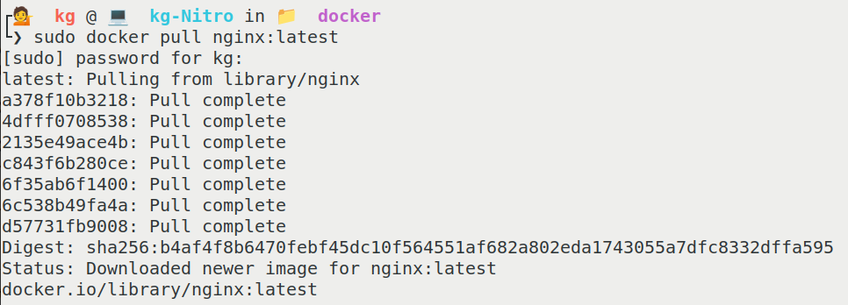

**Stop the Running Container using CLI**

1. In order to stop a running container use command **“docker stop contID”**.

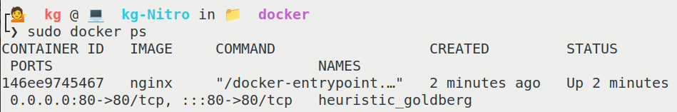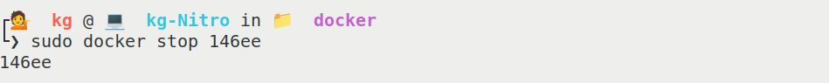

**Restart the container using CLI**

1. In order to restart a container use command **“docker restart contID”**.

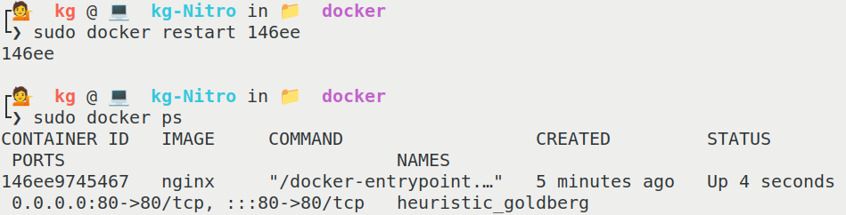

**Remove the container using CLI**

1. In order to remove a container first we have to stop the running container.
2. Then use command **“docker rm contID”**.

